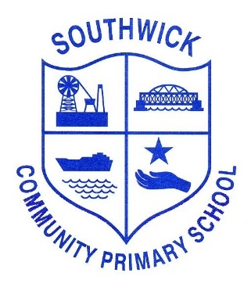

History Policy

2025-26

Introduction
At our school, we believe that studying history is an essential part of a child's education as it helps them understand the world around them and develop a sense of identity and belonging. Our History curriculum is designed to inspire curiosity, ignite imagination, and foster a love for learning about the past.

Aims
- To develop children's knowledge and understanding of chronology, events, and people in the past.
- To encourage children to ask questions, think critically, and form their own opinions based on historical evidence.
- To promote respect for diversity and different cultures through exploring a range of historical narratives.
- To develop children's skills in research, analysis, and communication through the study of history.

Curriculum
Our History curriculum is based on the 2014 National Curriculum in England and is organised into coherent and progressive sequences of study that build on prior learning. It is enriched with engaging resources, visits to historical sites, and opportunities for hands-on learning experiences.

Key Stage 1
- Children will learn about significant historical figures and events, including explorers, inventors, and the Great Fire of London.
- They will explore changes within living memory and the lives of significant individuals in the past.

Key Stage 2
- Children will study a broad range of historical periods, such as Ancient Egypt, the Roman Empire, the Anglo-Saxons, the Vikings, and the Benin Kingdom.
- They will develop a chronological framework of British history and make connections between different time periods.

Teaching and Learning
- History is taught through a combination of whole-class teaching, group work, independent research, and experiential learning activities.
- Teachers use a variety of primary and secondary sources to engage children in historical enquiry and interpretation.
- Cross-curricular links are made with subjects such as English, Art, and Geography to deepen children's understanding of historical events and concepts.

Assessment
- Children's progress in History is assessed through formative assessment strategies, such as observations, quizzes, and discussions.

Inclusion and Diversity
- Our History curriculum celebrates diversity and promotes inclusivity by ensuring that a wide range of perspectives and experiences are represented.
- Differentiation strategies are employed to cater to the needs of all learners, including those with special educational needs and disabilities.

Resources and Enrichment
- The school invests in high-quality history books, artefacts, and digital resources to support teaching and learning.
- Visits to museums, historical sites, and workshops are organised to enhance children's understanding of history in real-world contexts.
- Opportunities for historical reenactments, drama performances, and debates are provided to deepen children's engagement with the past.

Parental and Community Involvement
- Parents are encouraged to support their child's history learning by visiting historical sites, sharing family stories, and attending school events.
- Links with local historians, heritage organisations, and museums are established to enhance children's historical knowledge beyond the classroom.

