Southwick Community Primary School

Calculation Policy
A helpful guide to progressive maths teaching


Understanding the number system

A key priority of our maths curriculum is to ensure that children develop a strong sense of number and place value. Children will continually encounter numbers in the world around them, whether that be on the bus they took to school this morning or on their front door at home. But the ability to recognise the symbol 5, and name it, is very different from understanding the ‘fiveness’ of it, and it is the development of this latter skill that is crucial to a child’s mathematical ability.

Furthermore, it is important to recognise that just because a child can recite number names in order, does not necessarily mean that they can count. As with learning the alphabet, children can recall a sequence of numbers by rote without any real grasp or understanding of what they mean (hence young children often omit numbers as they count). Gaining familiarity with number names through songs and rhymes is of course helpful, but emphasis should be placed on helping children make links between these number names and the number of objects they equate to.

An intuitive sense of number begins at a very early age, and even before they start school, many children can identify one, two or three objects in a group, regardless of whether they can count. This ability to instantly compute the total in a small group of objects derives from stable, mental images of number which have developed over time from a variety of experiences with different patterns of number. For example, a child might immediately recognise the 6 on a dice, domino piece or playing card:

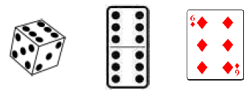

It is possible that the child has memorised this familiar arrangement of 6 dots.

Alternatively, they may have mentally sub-grouped them into two sets of 3, fostering an understanding that a number can be composed of smaller parts. In both cases, no actual counting of objects is involved; instead, the child has relied on other mental strategies.

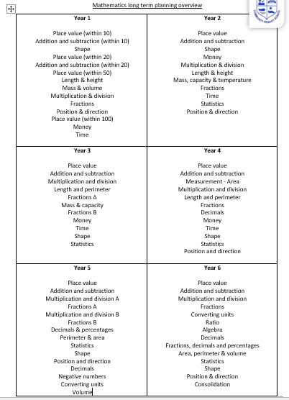
At Southwick, we follow the National Curriculum and have created our own long term plan.

Know and use numbers in the Early Years Foundation Stage:

In the Foundation Stage, as well as teaching the children to count objects, number recognition and the development of mental representations are key. In order to do this, much of their experience with number play in the early years will involve concrete, movable objects.
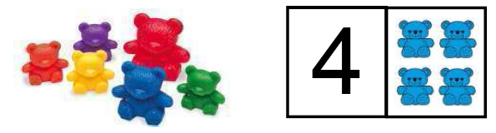

Use of Numicon is another great way to help children develop mental representations of number.
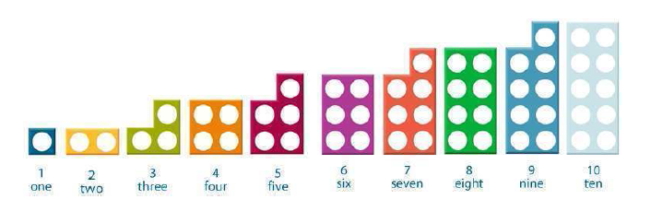
These experiences and number representations will help children:
- Count reliably with numbers from one to 20.
- Reliably count the number of objects in a set using the numbers one to twenty.
- Place numbers in order to 20.
- Say which number is one more or one less than a given number.
- Use objects to add two single-digit numbers by counting on to find the answer.

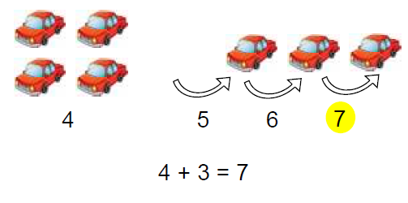

Key Stage One – Addition
Within this milestone, children will be working through three different levels of understanding, depending on their knowledge of the concept. The first generating an overall basic understanding of the concepts within the milestone, progressing onto a more advanced level of understanding, resulting in a deep knowledge and application of addition. Children will be able to apply their knowledge and understanding within a wide range of contexts.

Within this milestone children should:
- Have multiples experiences embedding the CPA approach to ensure conceptual understanding.
- Have access to number tracks, bead strings, number lines, diennes, place value counters, place value arrow cards, tens frame, Numicon, counting sticks, 100 squares, bar models and part whole models.
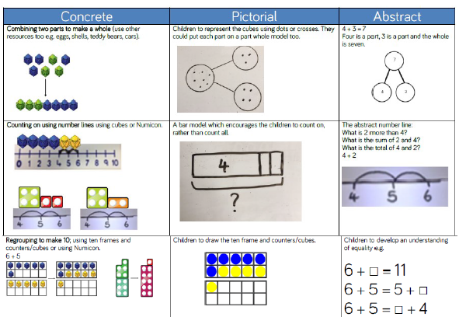
- Have access to a mathematical display highlighting the key vocab add, addition, plus, count on, total, sum, altogether, increase, more.

Use numbered number lines to add, by counting on in ones. Encourage children to start with the larger number and count on.
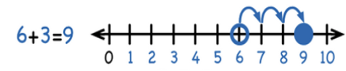
Begin with the CPA approach with partitioning of 2 digit numbers.
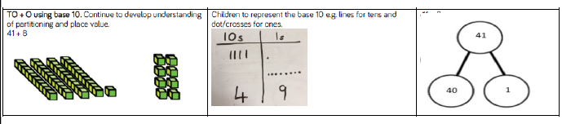
Addition skills will be broken down into adding 2-digit numbers and tens and also adding 2-digit numbers and ones, ensuring children have a full understanding of the process using the appropriate resources and method.
If necessary, children to record addition by partitioning and recombining to get the answer:
32 + 14 =
30 + 10 = 40
2 + 4 = 6
(40 + 6 = 46)
Add pairs of 2-digit numbers, moving to the partitioned column method when secure adding tens and ones following the CPA approach:
Step 1: Expanded column addition – no regrouping:
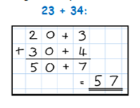

Step 2: Expanded column addition – with regrouping:
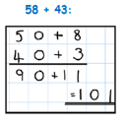

Children must also have a secure and rapid recall and understanding of these additive facts:
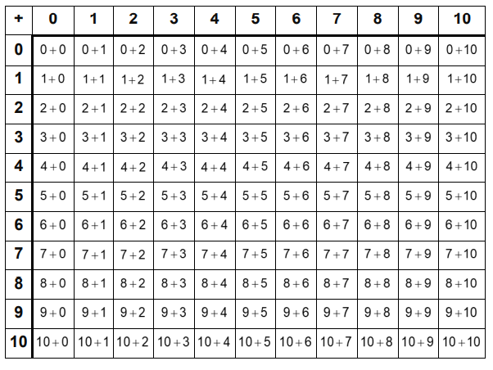
Milestone 2 - Addition
Within this milestone, children will be working through three different levels of understanding, depending on their knowledge of the concept. The first generating an overall basic understanding of the concepts within the milestone, progressing onto a more advanced level of understanding, resulting in a deep knowledge and application of addition. Children will be able to apply their knowledge and understanding within a wide range of contexts.
Milestone 2
Complexity | Solve two-step addition problems in contexts, deciding which operations and methods to use and why.
Methods | Add numbers with up to 4 digits using the formal written methods of columnar addition where appropriate.  Add numbers mentally, including:  A three-digit number and ones.  A three-digit number and tens.  A three-digit number and hundreds.
Checking | Estimate and use inverse operations to check answers to a calculation.
Using number facts | Solve problems, including missing number problems, using number facts, place value and more complex addition.

Again begin with the CPA approach:
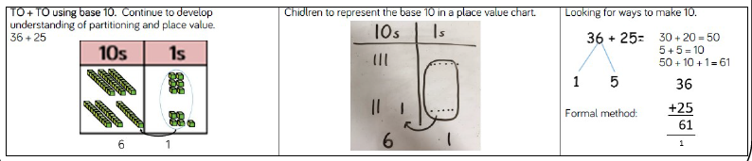

Use of place value counters to add HTO + TO, HTO +HTO etc. When there are 10 ones in the 1s column we exchange for 1 ten, when here are 10 tens in the 10s column we exchange for 1 hundred.

Children to represent the counters in a place value chart, circling when they make an exchange.

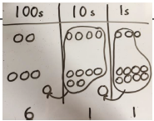
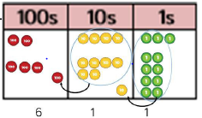

Following a CPA approach using a calculation mat or other resources suited to specific cohorts, introduce the column addition method using with no exchanging for 2, 3 and 4 digit numbers.
Column addition example with no exchanging:
232
+ 43
__ 275
Remind children the actual value is three tens add seven tens which equals ten tens, not three add seven.

Column addition example with exchanging:
HTO
236
+ 73
__309
1
‘Carry’ numbers underneath the bottom line as exchanging when subtracting will be above the numbers.

Add the ones first.
N.B:

Place value charts and calculation mats to be used, if needed, as visual aids and support tools in order to secure understanding of the addition process.

In addition to challenge through larger numerals, ensure challenge and deeper understanding are developed through ‘variation’ in the way addition problems are presented from here onwards.
Variation in Addition:
Once children can solve addition problems with 3 digit numbers, they can begin to apply this with 4 or more digits. However, once pupils have mastered addition up to and including 4-digits, it is important to ensure further challenge and deeper understanding are developed through ‘variation’ in the way addition problems are presented from here onwards.

Milestone 3 - Addition
Within this milestone, children will be working through three different levels of understanding, depending on their knowledge of the concept. The first generating an overall basic understanding of the concepts within the milestone, progressing onto a more advanced level of understanding, resulting in a deep knowledge and application of addition. Children will be able to apply their knowledge and understanding within a wide range of contexts.

Milestone 3
Complexity | Solve multi-step addition problems in contexts, deciding which operations and methods to use and why.
Methods | Add whole numbers with more than 4 digits, including using formal written methods. (columnar addition and subtraction)  Add numbers mentally with increasingly large numbers.
Checking | Use rounding to check answers to calculations and determine, in the context of a problem, levels of accuracy.
Using number facts | Add negative integers.
Add numbers with more than 4-digits including money, measures and decimals with different numbers of decimal places.
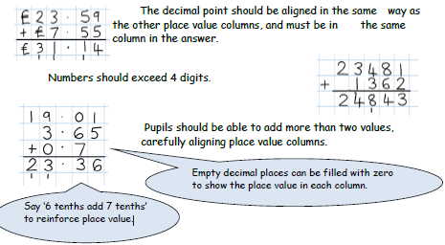

Children should:
Understand the place value of tenths and hundredths and use this to align numbers with different numbers of decimal places.
Add several numbers of increasing complexity.
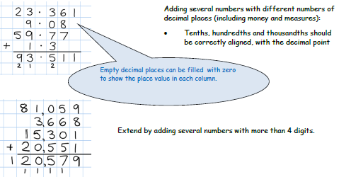
Pupils should also be able to perform mental calculations including with mixed operations and larger numbers.

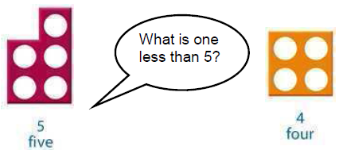
Subtraction in the Early Years Foundation Stage
- Say which number is one more or one less than a given number.

- Use objects to subtract two single-digit numbers by counting back to find the
answer.
The first step into subtraction is to learn how to count backwards.
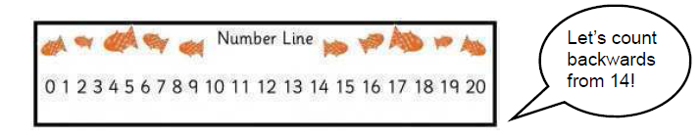
Children will then utilise this strategy to solve simple subtractions:
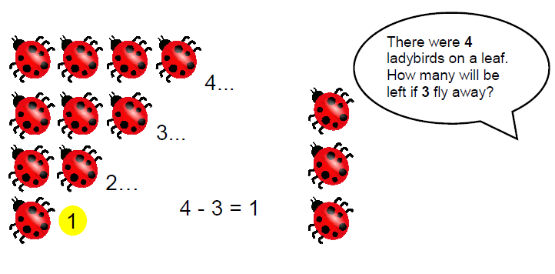

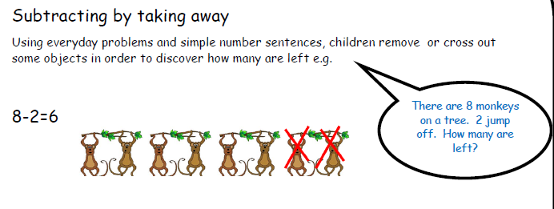
Subtract from numbers up to 10:

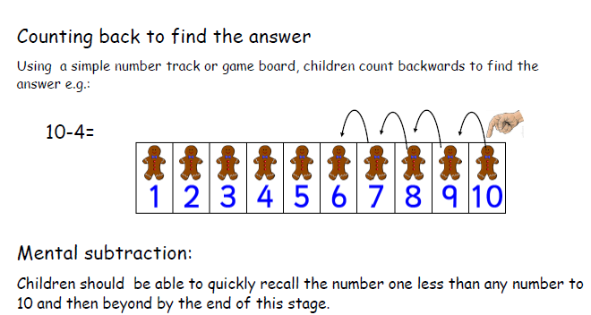

Milestone 1- Subtraction
Within this milestone, children will be working through three different levels of understanding, depending on their knowledge of the concept. The first generating an overall basic understanding of the concepts within the milestone, progressing onto a more advanced level of understanding, resulting in a deep knowledge and application of subtraction. Children will be able to apply their knowledge and understanding within a wide range of contexts.
Milestone 1
Complexity | Solve one-step problems with subtraction:  Using concrete objects and pictorial representations including those involving numbers, quantities and measures.  Using the subtraction (-) and equals (=) signs.  Applying their increasing knowledge of mental and written methods.
Methods | Subtract numbers using concrete objects, pictorial representations, and mentally, including:  One-digit and two-digit numbers to 20, including zero.  A two-digit number and ones.  A two-digit number and tens.  Two two-digit numbers.  Adding three one-digit numbers.  Show that addition of two numbers can be done in any order (commutative) and subtraction of one number from another cannot.
Checking | Recognise and use the inverse relationship between addition and subtraction and use this to check calculations and solve missing number problems.
Using number facts | Represent and use number bonds and related subtraction facts within 20.  Recall and use addition and subtraction facts to 20 fluently, and derive and use related facts up to 100.
Within this milestone children should:
- Have multiple experiences embedding the CPA approach to ensure conceptual understanding.
- Have access to number tracks, number lines, diennes, place value counters, place value arrow cards, tens frame, Numicon, counting sticks, 100 squares, bar models and part whole models.
- Have access to a mathematical display highlighting the key vocab subtract, takeaway, take from, difference, count back, inverse, less than, fewer than, decrease by, deduct, reduce, minus, exchange.

Subtract from numbers up to 20
Children consolidate understanding of subtraction practically, showing subtraction on number lines, using cubes etc. and in familiar contexts. They are introduced to more formal recording including recording on a number line once secure with the practical concept of subtraction.

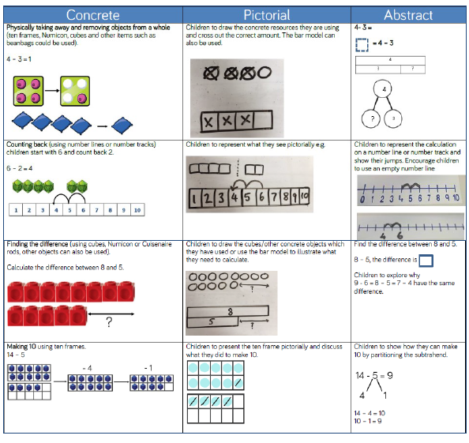
Children should start recalling subtraction facts up to and within 10 and 20 by the end of year 1 and should be able to subtract zero.
Subtraction skills will be broken down into subtracting 2-digit numbers and tens and also subtracting 2-digit numbers and ones, ensuring children have a full understanding of the process using the appropriate resources and method.
Children to record subtraction by partitioning and recombining to get the answer:
38 - 14 =
30 - 10 = 20
8 - 4 = 4
(Recombine numbers to get answers)
If children are secure in this method, move onto expanded column subtraction.

Milestone 2
Within this milestone, children will be working through three different levels of understanding, depending on their knowledge of the concept. The first generating an overall basic understanding of the concepts within the milestone, progressing onto a more advanced level of understanding, resulting in a deep knowledge and application of subtraction. Children will be able to apply their knowledge and understanding within a wide range of contexts.
Complexity | Solve two-step subtraction problems in contexts, deciding which operations and methods to use and why.
Methods | Subtract numbers with up to 4 digits using the formal written methods of columnar subtraction where appropriate.  Subtract numbers mentally, including:  A three-digit number and ones.  A three-digit number and tens.  A three-digit number and hundreds.
Checking | Estimate and use inverse operations to check answers to a calculation.
Using number facts | Solve problems, including missing number problems, using number facts, place value and subtraction that is more complex.

Subtract with 2-digit numbers:

Mental subtraction
Many mental strategies are to be taught. Children should be taught to recognise that when numbers are close together, it is more efficient to count on the difference making 10/using a number line if needed. They need to be clear about the relationship between addition and subtraction.
42-38=4

Within this milestone children should:
- Have multiples experiences embedding the CPA approach to ensure conceptual understanding.
- Have access to number tracks, number lines, diennes, place value counters, place value arrow cards, tens frame, Numicon, counting sticks, 100 squares, bar models and part whole models.
- Have access to a mathematical display highlighting the key vocab subtract, takeaway, take from, difference, count back, inverse, less than, fewer than, decrease by, deduct, reduce, minus, exchange.

Subtracting with 2 and 3-digit numbers:

Introduce partitioned column subtraction method.

Step 1: Begin with a CPA approach for a calculation where no ‘exchanging’ is required e.g.:
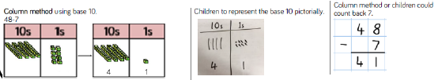

STEP 2: introduce ‘exchanging’ through practical subtraction. Make the larger number with diennes, then subtract 47 from it.
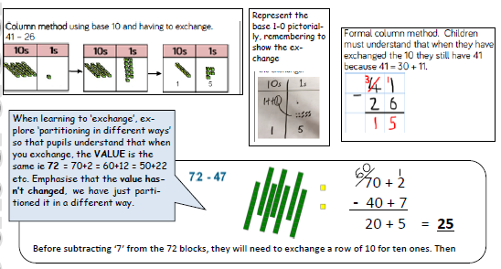

STEP 3: Use formal subtraction column method with exchanging.
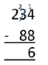
Subtract with up to 4-digit numbers
Partitioned column subtraction with ‘exchanging’ (decomposition):

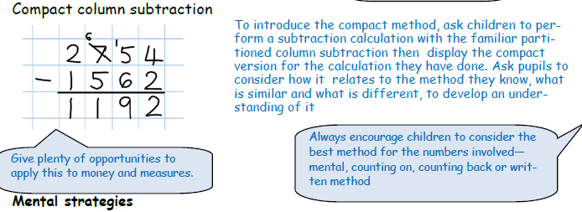

A variety of mental strategies must be taught and practised, including counting on to find the difference where numbers are closer together, or where it is easier to count on.

Milestone 3- Subtraction
Within this milestone, children will be working through three different levels of understanding, depending on their knowledge of the concept. The first generating an overall basic understanding of the concepts within the milestone, progressing onto a more advanced level of understanding, resulting in a deep knowledge and application of subtraction. Children will be able to apply their knowledge and understanding within a wide range of contexts.

Complexity | Solve multi-step subtraction problems in contexts, deciding which operations and methods to use and why.
Methods | Subtract whole numbers with more than 4 digits, including using formal written methods. (columnar addition and subtraction)  Subtract numbers mentally with increasingly large numbers
Checking | Use rounding to check answers to calculations and determine, in the context of a problem, levels of accuracy.
Using number facts | Subtract negative integers.

Subtract with at least 4-digit numbers including money, measures and decimals.
Compact column subtraction (with ‘exchanging’).

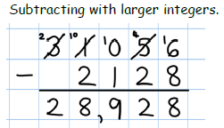
Children who are still not secure with number facts and place value will need to remain on the partitioned column method until ready for the compact method.

Subtract with decimal values, including mixtures of integers and decimals, aligning the decimal point.
Add a ‘zero’ in any empty decimal places to aid understanding of what to subtract in that column.
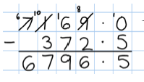

Subtracting with increasingly large and more complex numbers and decimal values.
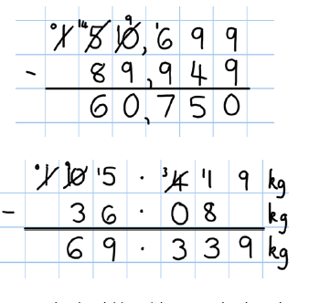
Using the compact column method to subtract more complex integers

Using the compact column method to subtract money and measures, including decimals with different numbers of decimal places.
Pupils should be able to apply their knowledge of a range of mental strategies, mental recall skills, and informal and formal written methods when selecting the most appropriate method to work out subtraction problems.
Variation in subtraction
Children should be given frequent opportunities for variation in how problems are presented or, in how they may be expected to solve them.
For Example:

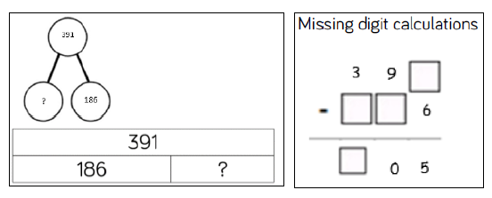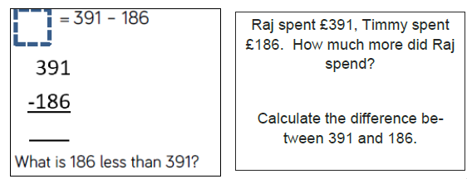

Multiplication:

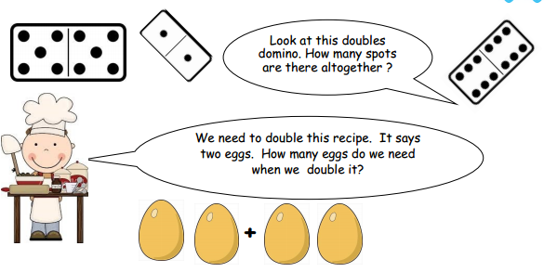
Early years Foundation Stage
Doubling

- Children need experience of solving everyday problems where double the quantity is needed (e.g. double the amount of toast, double the amount of forks at the dinner table or double the number of cups at snack time).
- Children may begin some quick recall of doubles facts such as, “Double 2 is 4,” through game playing e.g. roll a dice then double the number it lands on.

Milestone 1

Within this milestone, children will be working through three different levels of understanding, depending on their knowledge of the concept. The first generating an overall basic understanding of the concepts within the milestone, progressing onto a more advanced level of understanding, resulting in a deep knowledge and application of multiplication. Children will be able to apply their knowledge and understanding within a wide range of contexts.

Complexity | Solve one-step (two-step at greater depth) problems involving multiplication.
Methods | Calculate mathematical statements for multiplication within the multiplication tables and write them using the multiplication (x) and equals (=) signs.  Show that multiplication of two numbers can be done in any order (commutative).  Solve problems involving multiplication using mental methods.
Checking | Use known multiplication facts to check the accuracy of calculations.
Using number facts | Recall and use multiplication facts for the 2, 5 and 10 multiplication tables.  Recognise odd and even numbers.  Use multiplication facts to solve problems.

Within this milestone children should:
- Have multiples experiences embedding the CPA approach to ensure conceptual understanding.
- Have access to number tracks, number lines, diennes, place value counters, place value arrow cards, tens frame, Numicon, counting sticks, 100 squares and bar models.
- Have access to a mathematical display highlighting the key vocab including multiply, multiplication, times, lots of, groups of, sets of, product, multiple, double, factors, repeated addition and distributive.

Multiply with concrete objects, arrays and pictorial representations:
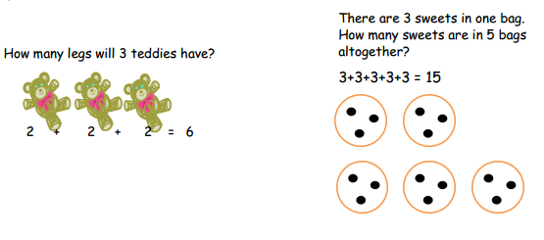
- Give children experience of counting equal group of objects in 2s, 5s and 10s

- Present practical problem solving activities involving counting equal sets or groups

Multiply using arrays and repeated addition (using at least 2s, 5s and 10s)
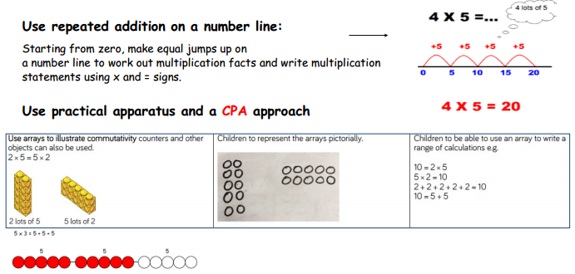

Use mental recall:
- Children should begin to recall multiplication facts for 2, 5 and 10 times tables and count in 3s through practice in counting and understanding of the operation.

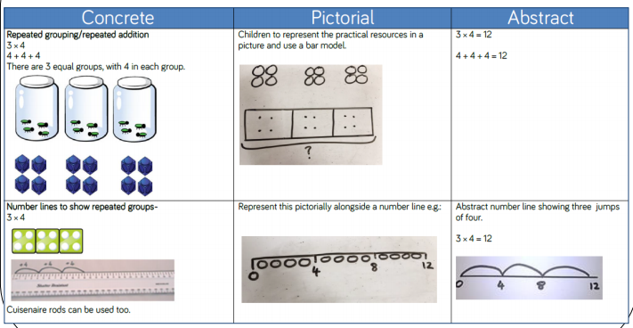
The CPA approach in milestone 1 should look like this:

Milestone 2
Within this milestone, children will be working through three different levels of understanding, depending on their knowledge of the concept. The first generating an overall basic understanding of the concepts within the milestone, progressing onto a more advanced level of understanding, resulting in a deep knowledge and application of multiplication. Children will be able to apply their knowledge and understanding within a wide range of contexts.
Complexity | Solve problems involving multiplying, including using the distributive law to multiply two digit numbers by one digit, integer scaling problems and harder correspondence problems (such as n objects are connected to m objects).
Methods | Multiply two-digit and three-digit numbers by a one-digit number using formal written layout.  Use place value, known and derived facts to multiply mentally, including: multiplying by 0 and 1; dividing by 1; multiplying together three numbers.  Recognise and use factor pairs and commutativity in mental calculations.
Checking | Recognise and use the inverse relationship between multiplication and division and use this to check calculations and solve missing number problems.
Using number facts | Recall multiplication facts for multiplication tables up to 12 × 12.

Multiply 2-digits by a single digit number
Begin with objects then record pictorially before more abstract recording
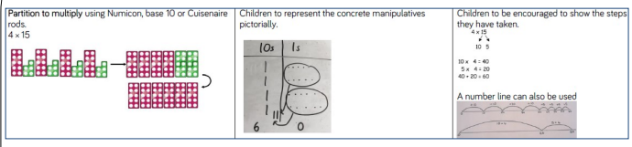

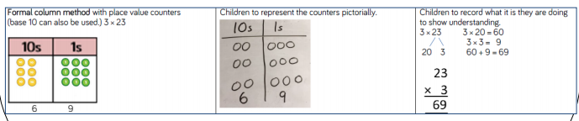

As a pre-step before formal column, grid method can be used, if required, to consolidate place value knowledge. It is up to the teacher to make the judgement whether the method is used or not.
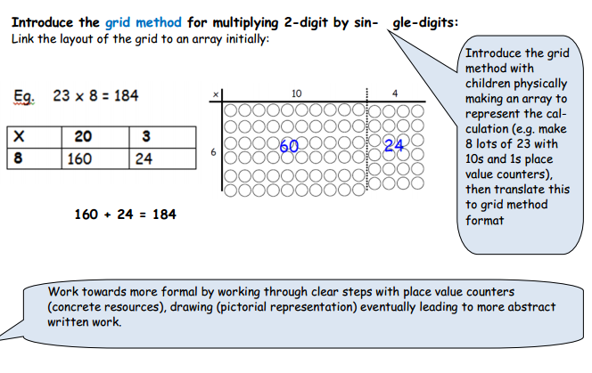

Multiply 2 and 3-digits by a single digit, using all multiplication tables up to 12 x 12
Review and extend the Concrete, Pictorial and Abstract (CPA) approach. Apply this to three digit numbers.
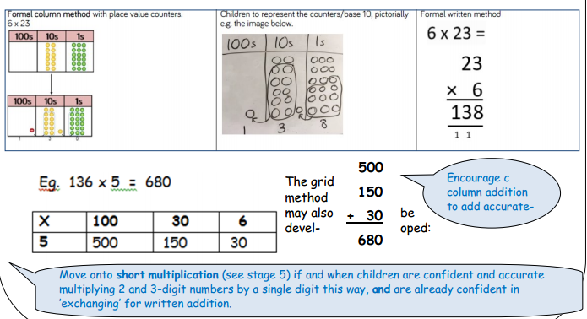

Milestone 3
Within this milestone, children will be working through three different levels of understanding, depending on their knowledge of the concept. The first generating an overall basic understanding of the concepts within the milestone, progressing onto a more advanced level of understanding, resulting in a deep knowledge and application of multiplication. Children will be able to apply their knowledge and understanding within a wide range of contexts.
Complexity | Solve problems involving multiplication, including understanding the meaning of the equals sign.  Solve problems involving multiplication, including scaling by simple fractions and problems involving simple rates.  Use knowledge of the order of operations to carry out calculations involving the four operations.
Methods | Multiply multi-digit numbers up to 4 digits by a two-digit whole number using the formal written method of long multiplication.  Perform mental calculations, including with mixed operations and large numbers.
Checking | Estimate and use inverse operations and rounding to check answers to a calculation.
Using number facts | Identify common factors, common multiples and prime numbers.  Establish whether a number up to 100 is prime and recall prime numbers up to 19.  Multiply whole numbers and those involving decimals by 10, 100 and 1000.  Recognise and use square numbers and cube numbers, and the notation for squared (2) and cubed (3).  Solve problems involving multiplication, including using knowledge of factors and multiples, squares and cubes.

Multiply up to 4-digits by 1 or 2 digits.
Introducing column multiplication
- Introduce by comparing a grid method calculation to a short multiplication method, to see how the steps are related, but notice how there are less steps involved in the column method
- Children need to be taught to approximate first, e.g. for 72 x 38, they will use rounding: 72 x 38 is approximately 70 x 40 = 2800, and use the approximation to check the reasonableness of their answer against.
Pupils could be asked to work out a given calculation using the grid, and then compare it to ‘your’ column method. What are the similarities and differences?
Unpick the steps and show how it reduces the steps needed.

Short multiplication for multiplying by a single digit
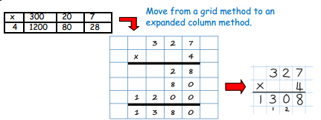
18 x 3 on the 1st row (8 x 3 = 24, exchanging the 2 for twenty, then ‘1’ x 3).
18 x 10 on the 2nd row. Put a zero in ones first, then say 8 x 1, and 1 x 1.

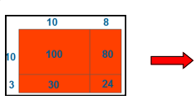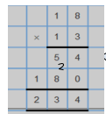
The grid could be used to introduce long multiplication, as the relationship can be seen in the answers in each row.

Introduce long multiplication for multiplying by 2 digit:
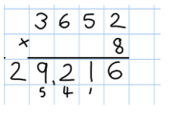
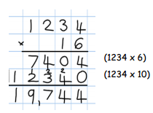
Moving onto more complex numbers:
Short and long multiplication as in Stage 5, and multiply decimals with up to 2d.p by a single digit.
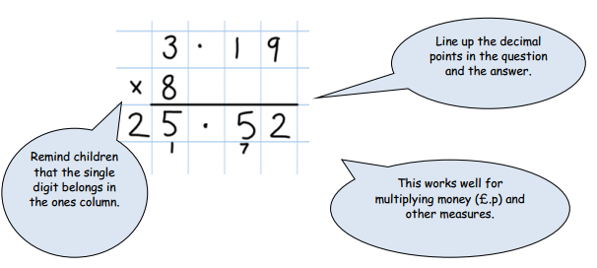
Children will be able to:
- Use rounding and place value to make approximations before calculating and use these to check answers against.
- Use short multiplication (see ARE 5) to multiply numbers with more than 4-digits by a single digit; to multiply money and measures, and to multiply decimals with up to 2d.p. by a single digit.
- Use long multiplication (see ARE 5) to multiply numbers with at least 4 digits by a 2-digit numbers.

Variation in Multiplication
Children should be given frequent opportunities for variation in how problems are presented or, in how they may be expected to solve them. An ability to solve problems in a variety of ways deepens children’s understanding.
Some examples include:
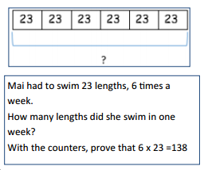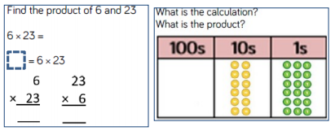

Division:
Division in the Early Years Foundation Stage
Solve practical problems involving halving and sharing

How many cakes on the plate? Take half of them off.
How many did you take off? How many are left?
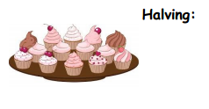

Other questions might include: Put half of: the sheep in the field… the cars in the garage…the dinosaurs in the forest… the animals in the zoo…

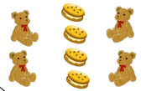
Can you share the biscuits out between the teddies? How many biscuits does each teddy get?
biscuits does each teddy get?
Find half a group of objects by sharing into 2 equal groups.
Share a group of objects fairly between themselves and others

Milestone 1
Within this milestone, children will be working through three different levels of understanding, depending on their knowledge of the concept. The first generating an overall basic understanding of the concepts within the milestone, progressing onto a more advanced level of understanding, resulting in a deep knowledge and application of division. Children will be able to apply their knowledge and understanding within a wide range of contexts.

Complexity | Solve problems involving division, including using the distributive law to divide two digit numbers by one digit, integer scaling problems and harder correspondence problems (such as n objects are connected to m objects).
Methods | Dividing -digit and two-digit numbers by a one-digit number using formal written layout.  Use place value, known and derived facts to divide mentally, including: dividing by 1; dividing together three numbers.
Checking | Recognise and use the inverse relationship between multiplication and division and use this to check calculations and solve missing number problems.
Using number facts | Recall division facts for multiplication tables up to 12 × 12.

Group and share small quantities:
Using objects, diagrams and pictorial representations to solve problems involving both grouping and sharing.
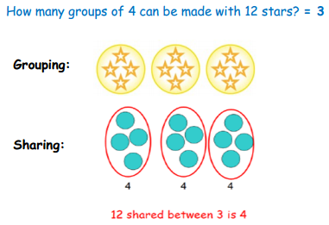
Pupils should:
Use lots of practical apparatus, arrays and picture representations
Be taught to understand the difference between ‘grouping’ objects (How many groups of 2 can you make?) and ‘sharing’ (Share these sweets between 2 people)
Be able to count in multiples of 2s, 5s and 10s.
Find half of a group of objects

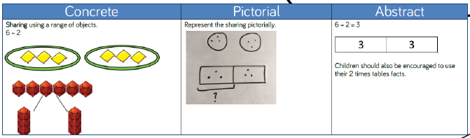

Group and share, using the ÷ and = sign
Use objects, arrays, diagrams and pictorial representations, and grouping on a number line.
This represents 12 ÷ 3, posed as how many groups of 3 are in 12?

Pupils should also show that the same array can represent 12 ÷ 4 = 3 if grouped horizontally.
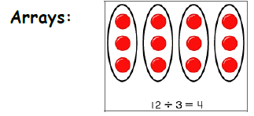

To know and understand sharing and grouping:

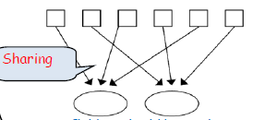
sharing
Grouping

Milestone 2
Within this milestone, children will be working through three different levels of understanding, depending on their knowledge of the concept. The first generating an overall basic understanding of the concepts within the milestone, progressing onto a more advanced level of understanding, resulting in a deep knowledge and application of division. Children will be able to apply their knowledge and understanding within a wide range of contexts.
Complexity | Solve problems involving division, including using the distributive law to divide two digit numbers by one digit, integer scaling problems and harder correspondence problems (such as n objects are connected to m objects).
Methods | Dividing two-digit and three-digit numbers by a one-digit number using formal written layout.  Use place value, known and derived facts to divide mentally, including: dividing by 0 and 1; dividing by 1; diving into three numbers.  Recognise and use factor pairs and commutativity in mental calculations.
Checking | Recognise and use the inverse relationship between multiplication and division and use this to check calculations and solve missing number problems.
Using number facts | Recall division facts for multiplication tables up to 12 × 12.

Divide 2-digit numbers by a single digit:
STEP 1: Once children are secure with division as grouping and demonstrate this using number lines, arrays etc., short division for larger 2-digit numbers should be introduced, initially with carefully selected examples requiring no calculating of remainders at all.
Remind children of correct place value, that 96 is equal to 90 and 6, but in short division, pose:
How many 3’s in 9? = 3, and record it above the 9 tens.
How many 3’s in 6? = 2, and record it above the 6 ones.

Short division:
Limit numbers to NO remainders
in the answer OR carried
STEP 2: Once children demonstrate a full understanding of remainders using non formal methods, and also the short division method taught, they can be taught how to use the method when remainders occur within the calculation (e.g. 96÷4), and be taught to ‘carry’ the remainder onto the next digit.

Short division:
Limit numbers to NO remainders in the final answer, but with remainders occurring within the calculation to be carried to the next digit.

Step 3 must only be taught when pupils can calculate ‘remainders’.

Divide up to 3-digit numbers by a single digit (without remainders initially).

Continue to develop short division:

Pupils move onto dividing numbers with up to 3-digits by a single digit, however problems and calculations provided should not result in a final answer with remainder at this stage.

When the answer for the first column is zero (1 ÷ 5, as in example), children could initially write a zero above to acknowledge its place, and must always ‘carry’ the number (1) over to the next digit as a remainder.
Include money and measure contexts when confident.

Milestone 3
Within this milestone, children will be working through three different levels of understanding, depending on their knowledge of the concept. The first generating an overall basic understanding of the concepts within the milestone, progressing onto a more advanced level of understanding, resulting in a deep knowledge and application of division. Children will be able to apply their knowledge and understanding within a wide range of contexts.
Complexity | Solve problems involving addition, subtraction, multiplication and division and a combination of these, including understanding the meaning of the equals sign.  Solve problems involving division, including scaling by simple fractions and problems involving simple rates.  Use knowledge of the order of operations to carry out calculations involving the four operations.
Methods | Divide numbers up to 4 digits by a two-digit whole number using the formal written method of long division, and interpret remainders as whole number remainders, fractions, or by rounding, as appropriate for the context.  Perform mental calculations, including with mixed operations and large numbers.
Checking | Estimate and use inverse operations and rounding to check answers to a calculation.
Using number facts | Divide whole numbers and those involving decimals by 10, 100 and 1000.  Recognise and use square numbers and cube numbers, and the notation for squared (2) and cubed (3).  Solve problems involving multiplication and division including using knowledge of factors and multiples, squares and cubes.

Divide up to 4 digits by a single digit, including those with remainders.
Short division, including remainder answers:
Short division with remainders: Now that pupils are introduced to examples that give rise to remain-der answers, division needs to have a real life problem solving context, where pupils consider the meaning of the remainder and how to express it, as a fraction, a decimal, or as a rounded number or value, depending upon the context of the problem.

The answer to 5309 ÷ 8 could be expressed as 663 and five eighths, 663 r 5, as a decimal, or rounded as appropriate to the problem involved.

Divide at least 4 digits by both single-digit and 2-digit numbers (including decimal numbers and quantities).
Short division, for dividing by a single digit: e.g. 6497 ÷ 8
Short division with remainders: Pupils should continue to use this method, but with numbers to at least 4 digits, and understand how to express remainders as fractions, decimals, whole number remainders, or rounded numbers. Real life problem solving con-texts need to be the starting point, where pupils have to consider the most appropriate way to express the remainder.

Calculating a decimal remainder: In this example, rather than expressing the remainder as r 1, a decimal point is added after the ones because there is still a remainder, and the one remainder is carried onto zeros after the decimal point (to show there was no decimal value in the original number). Keep dividing to an appropriate degree of accuracy for the problem being solved.
Introduce long division for dividing by 2 digits.

1. If the divisor is bigger than 12 then list the multiples of that number by doubling etc. e.g.

1x = 36
2 x = 72
3 x = 108
4 x = 144
5 x = 180

2. Set out the calculation as in the ‘bus stop method’
3. Look at the largest column of the dividend and see if that column is divisible by the divisor (e.g. 9 in the example here). If not, use the next column to help (e.g. 7 in the example here – looking at this number as if it is now 97).
4. Place the total number of groups that you get from this calculation (e.g. 97÷36= 2 groups, with a remainder of 25)
5. Multiply the total number of groups in step 4 by the divisor (e.g. 2 x 36=72) and write the answer underneath the first two columns.
6. Subtract the 72 from the 97 to show the remainder – lining the remainder up underneath.
7. Of the dividend, you will have one or more unused digits (number 2 in the example) which you bring down next to the remainder (25) to create the new number “252”. This number now becomes the dividend and you now see how many groups of the divisor go into that group.

Step 7 (above) may be repeated several times depending on the number of digits in the dividend and the context of the problem. If it is money/a decimal problem, columns of zeros may be needed to bring down. You will be left with a single digit remainder, depending on the contexts of the problem (as in the example here).
When dropping down digits to join the remainder, treat this as a whole number, ignoring the decimal for this part of the problem but ensuring it remains in the bus stop (i.e. the decimal must remain in the quotient and dividend line)

The following acronym may help with remembering which steps to take in long division problems:
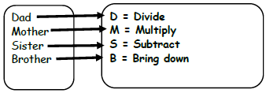
Variation in Division

Children should be given frequent opportunities for variation in how problems are presented or, in how they may be expected to solve them. An ability to solve problems in a variety of ways deepens children’s understanding.
These examples are taken from the White Rose calculation policy showing different ways to ask children to solve 615/5, but is equally applied to larger values:

Also include money and measure contexts.

Please see the Essentials curriculum for additional curriculum coverage and milestone indicators for the following areas:
- Fractions
- Understanding the properties of shape
- Measures
- Statistics
- Algerbra

