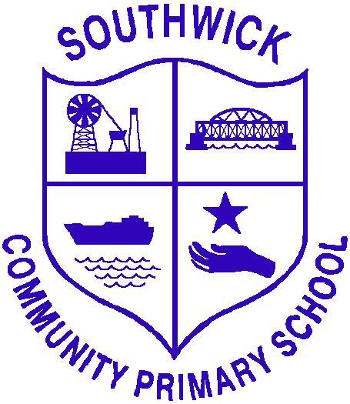
Whole-School Geography Policy

Intent

At Southwick Community Primary School, our Geography curriculum aims to inspire pupils’ curiosity about the world, its people, and environments.
We seek to equip children with:
- Secure knowledge of places, people, and processes shaping our world.
- Geographical skills to collect, interpret, and present information using maps, globes, and digital technology.
- Understanding of the relationship between human and physical geography.
- A respect for the environment and an awareness of global citizenship.

Our curriculum is progressive from EYFS to Year 6, ensuring full coverage of the National Curriculum. Units are carefully sequenced to build knowledge, skills, and enquiry, beginning with children’s immediate experiences and expanding to global perspectives.

Implementation

EYFS
Through the Understanding the World strand, children will:
- Explore their school and local environment.
- Observe seasonal and weather changes.
- Begin to use geographical language (e.g., road, town, map, shop, park).
- Learn about different countries and cultures through celebrations, stories, and play.

KS1
Year 1
- Term 1: Seasons – How does the weather change through the year?
- Term 2: Continents and Oceans – What can we find out about the world?
- Term 3: Local Area – Where do we live?
Year 2
- Term 1: Life in a Capital City – What is life like in London?
- Term 2: Extreme Places – What are hot and cold regions like?
- Term 3: Contrasting Locality – What is it like to live in Tanzania?

Focus in KS1:
- Naming continents, oceans, and the countries of the UK.
- Understanding simple physical and human features.
- Using maps, photographs, and fieldwork to study the local area.

KS2
Year 3
- Term 1: The Water Cycle – Why is it important?
- Term 2: Climate Zones – What are they and why do they matter?
- Term 3: Land Use – How diverse are local and UK landscapes?
Year 4
- Term 1: Europe – How diverse are its landscapes and places?
- Term 2: Mountains and Volcanoes – What, where and why?
- Term 3: UK Region – Why is Northumberland a national park?
Year 5
- Term 1: Energy – How do we power the world?
- Term 2: South America – Why does the Amazon matter?
- Term 3: Local and Global – Why are trees and forests important?
Year 6
- Term 1: Earthquakes – How do they change the world?
- Term 2: Farms and Factories – Where does our food come from?
- Term 3: Coasts – What happens where the land meets the sea?

Focus in KS2:
- Locating countries, cities, and significant geographical features.
- Studying contrasting regions of the UK, Europe, and the wider world.
- Understanding physical processes (e.g., rivers, coasts, volcanoes, climate).
- Exploring human geography (settlements, land use, trade, energy, resources).
- Developing fieldwork, mapping, and enquiry skills.

Teaching & Learning Approaches

- Enquiry-based learning led by key questions.
- Cross-curricular links (science, history, art, literacy).
- Fieldwork and outdoor learning, especially in the local environment.
- Use of resources such as maps, globes, atlases, digital mapping tools.
- Differentiated activities to ensure inclusivity and accessibility.

Assessment

- Ongoing formative assessment through observation, discussion, and written work.
- End-of-unit tasks to evidence knowledge and enquiry skills.
- Pupil voice used to evaluate engagement and progression.
- Summative assessments/retrieval activities tracked across year groups to ensure progression.

Impact

By the end of Year 6, pupils will:
- Have a strong sense of place, space, and scale at local, national, and global levels.
- Be able to interpret and present geographical information using maps, diagrams, and digital tools.
- Understand human and physical processes shaping the Earth.
- Be inquisitive, respectful, and responsible global citizens.
- Be fully prepared for geography at secondary school.

Leadership, Monitoring & Review

- The Geography Subject Leader monitors planning, teaching, and outcomes.
- Regular CPD provided for staff to strengthen subject knowledge.
- Policy reviewed every two years to ensure it reflects curriculum developments and school priorities.

Equality & Inclusion

We ensure our Geography curriculum:
- Represents diverse cultures, people, and environments.
- Promotes respect, empathy, and responsibility.
- Is accessible to all learners, including those with SEND.

