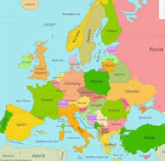
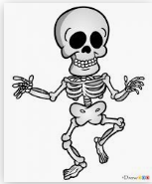
Year 3 homework – Summer 2

You should choose 1 activity from the grid each week. Good Luck and we can’t wait to see the work you produce! You should also practise your times tables and your weekly spellings.
Geography  Can you research 10 facts about Sunderland? | History  Create a poster to show everything you have learned in History this year?  (The Stone Age, World War 1, Titanic, The Romans, Our local area) | Spanish  Create a calendar showing the months of the year in Spanish. | Maths  Create a map of a short walk you do at home. Can you label the directions you travel?  (North, East, South, West)  Can you label the human and physical features you pass?
Literacy  Could you write about your experiences on our trip to the glass centre? | Art / D&T  Research 5 facts about Pablo Picasso.  Challenge: Can you try to replicate one of his paintings? | Jigsaw  Think of 5 things you are looking forward to about going into Year 4. | Science  Design a healthy plate making sure you have foods from each of the food groups.

