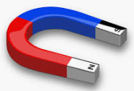
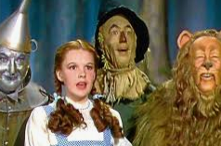
Year 3 homework – Spring 1

You should choose 1 activity from the grid each week. Each task is worth up to a different amount of points depending on the difficulty and effort shown. Points will be totalled at the end of each half term and those children with the highest points score will receive a prize! Good Luck and we can’t wait to see the work you produce! You should also practise your times tables and your weekly spellings.
Geography  Label a map of Europe with countries and capital cities.  For extra points can you make a key to represent the colours you have coloured each country?  (up to 10 points) | R.E.  Research 5 facts about the Jewish religion.  (Up to 5 points) | Spanish  Draw 6 common food items and label them in Spanish. Don’t forget to colour them in!  (up to 6 points) | Maths  Use a ruler to measure and record the lengths of 10 different items in your house.  For extra points can you order them from shortest to longest?  (up to 6 points)
Literacy  Write a short story about waking up in a magical land. What would you see there? What happens while you are there?  (Up to 10 points) | Art / D&T  Choose a character from the Wizard of Oz. Can you sketch and colour this character?  (up to 8 points) | Jigsaw  Create a poster to show your goals and dreams. What do you want to be when you grow up? What are your goals for the end of this year?  (up to 6 points) | Science  Draw and label different pushes and pulls around your home. Think about the way the force arrow will point.  (Up to 6 points)

