Reading at Southwick Community Primary School
Reading at School
From Nursery to Year 6 we love to read. We have a variety of books in school and give the children a number of opportunities to read and use their reading skills throughout the day. At School we are also promoting Reading for Pleasure, where along with their RWI or stage book, they will be given a book that they really enjoy reading.
As part of a new initiative – ‘Southwick Community Primary School Reads’ - we will be handing out prizes for reading. For every book your child reads they will be given a stamp on our new ‘Reading Reward Cards’ and when they reach 10, 20, 30etc. They will get their prizes from ‘The Reading Shop’, which will be ran by Year 6 Reading Ambassadors. This has all been put together to show the children how important reading is.
Throughout the year staff in school will be recommending books for the children, there will be a variety of trips organised to encourage reading, children will have the opportunity to read in ALL subjects and we will also be celebrating international, national and even local authors.
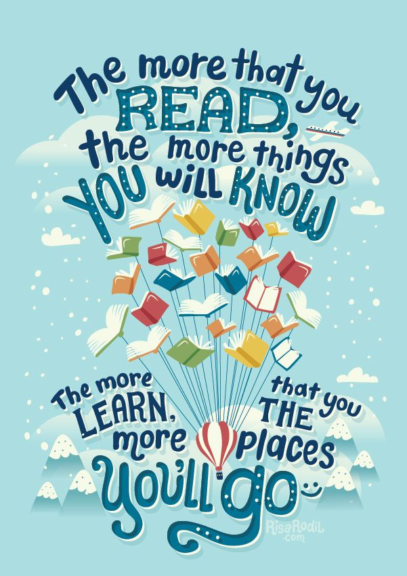
Reading at Home
What should parents do at home to support their child’s development?
- First of all, reading should be fun and exciting
- Your child should read for at least 15 minutes every night
- You should listen to your child every night - doing this can improve their fluency skills and help develop your child’s love of reading
- You should read to your child – this will help them understand how to use expression to bring stories to life and develop their own voice as readers
- After listening to them, or reading to them, ask them some questions – you will all be provided with some great questions to ask your child from school
- Talk about the meaning of new words – if you are unsure about a word you can even write it in their home reader and their teacher can help them in school
- Read a variety of books – school can help you and your child choose different books to read
- Read the same book again and again if you have to – your child’s book will only be changed if their teacher thinks they are ready. This is to support their reading improvement and the overlearning of unknown words and phrases

Learn To Read – Read To Learn – Love To Read
If you have any questions about Reading in and out of school – don’t hesitate to ask.

