Save the World Week
week commencing 20th January 2020

In January, we are going to have a ‘Save the World’ week at school. Each year group will be given a topic and your lessons that week should be focused around this topic.
At the end of the week, each year group will have work produced related to their topic. This could be poems, posters, persuasive letters etc. We can also try and get a board and display the children’s work.
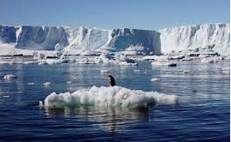
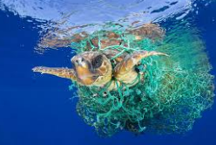
Year 1 Year 2 Year 3
Recycling materials Plastic in the ocean Melting ice caps
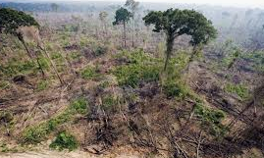
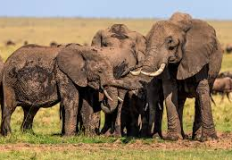
Year 4 Year 5 Year 6
Illegal poaching Deforestation Reduce carbon footprint

