Understand texts – This concept involves understanding both the literal and more subtle nuances of texts.
• Discuss events.
• Predict events.
• Link reading to own experiences and other books.
• Join in with stories or poems.
• Check that reading makes sense and self-correct.
• Infer what characters are like from actions.
• Ask and answer questions about texts.
• Discuss favourite words and phrases.
• Listen to and discuss a wide range of texts.
• Recognise and join in with (including role-play) recurring language.
• Explain and discuss understanding of texts.
• Discuss the significance of the title and events.
• Make inferences on the basis of what is being said and done.

Read words accurately – This concept involves decoding and fluency
• Apply phonic knowledge and skills as the route to decode words.
• Respond speedily with the correct sound to graphemes (letters or groups of letters) for all 40+ phonemes, including, where applicable, alternative sounds for graphemes.
• Read accurately by blending sounds in unfamiliar words containing GPCs that have been taught.
• Read common exception words, noting unusual correspondences between spelling and sound and where these occur in the word.
• Read words containing taught GPCs and –s, –es, –ing, –ed, –er and –est endings.
• Read other words of more than one syllable that contain taught GPCs.
• Read words with contractions (for example, I’m, I’ll, we’ll) and understand that the apostrophe represents the omitted letter(s).
• Read aloud accurately books that are consistent with phonic knowledge and that do not require other strategies to work out words.
• Re-read these books to build up fluency and confidence in word reading.
• Read accurately by blending the sounds in words that contain the graphemes taught so far, especially recognising alternative sounds for graphemes.
• Read accurately words of two or more syllables that contain the same graphemes as above.
• Read words containing common suffixes.
• Read most words quickly and accurately, without overt sounding and blending, when they have been frequently encountered.
• Read aloud books closely matched to their improving phonic knowledge, sounding out unfamiliar words accurately, automatically and without undue hesitation.
• Re-read books to build up fluency and confidence in word reading.

Milestone 1 - Year 1 & 2

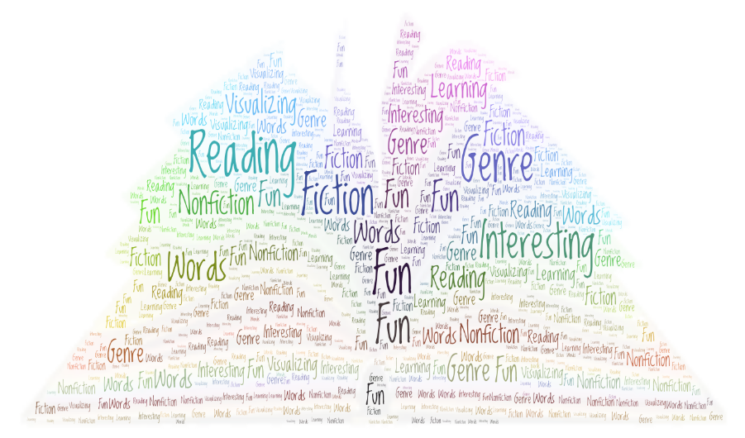

Understand texts – This concept involves understanding both the literal and more subtle nuances of texts.
• Draw inferences from reading.
• Predict from details stated and implied.
• Recall and summarise main ideas.
• Discuss words and phrases that capture the imagination.
• Retrieve and record information from non-fiction, using titles, headings, sub-headings and indexes.
• Prepare poems and plays to read aloud with expression, volume, tone and intonation.
• Identify recurring themes and elements of different stories (e.g. good triumphing over evil).
• Recognise some different forms of poetry.
• Explain and discuss understanding of reading, maintaining focus on the topic.
• Draw inferences such as inferring characters’ feelings, thoughts and motives from their actions, and justifying inferences with evidence.
• Predict what might happen from details stated and implied.
• Identify main ideas drawn from more than one paragraph and summarise these.
• Identify how language, structure and presentation contribute to meaning.
• Ask questions to improve understanding of a text.

Milestone 2 - Year 3 & 4
Read words accurately – This concept involves decoding and fluency
• Apply a growing knowledge of root words, prefixes and suffixes (etymology and morphology).
• Read further exception words, noting the spellings.

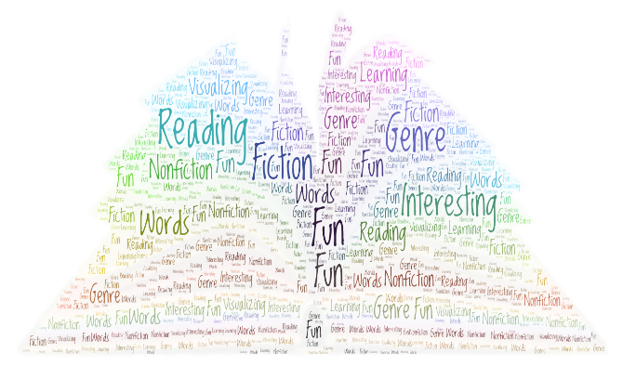

Read words accurately – This concept involves decoding and fluency
• Apply knowledge of root words, prefixes and suffixes.
• Read age-appropriate books with confidence and fluency (including whole novels).
(Note: this should be through normal reading rather than direct teaching.)

Understand texts – This concept involves understanding both the literal and more subtle nuances of texts.
• Recommend books to peers, giving reasons for choices.
• Identify and discuss themes and conventions in and across a wide range of writing.
• Make comparisons within and across books.
• Learn a wide range of poetry by heart.
• Prepare poems and plays to read aloud and to perform, showing understanding through intonation, tone and volume so that the meaning is clear to an audience.
• Check that the book makes sense, discussing understanding and exploring the meaning of words in context.
• Ask questions to improve understanding.
• Draw inferences such as inferring characters’ feelings, thoughts and motives from their actions, and justifying inferences with evidence.
• Predict what might happen from details stated and implied.
• Summarise the main ideas drawn from more than one paragraph, identifying key details that support the main ideas.
• Identify how language, structure and presentation contribute to meaning.
• Discuss and evaluate how authors use language, including figurative language, considering the impact on the reader.
• Retrieve and record information from non-fiction.
• Participate in discussion about books, taking turns and listening and responding to what others say.
• Distinguish between statements of fact and opinion.
• Provide reasoned justifications for views.

Milestone 3 - Year 5 & 6

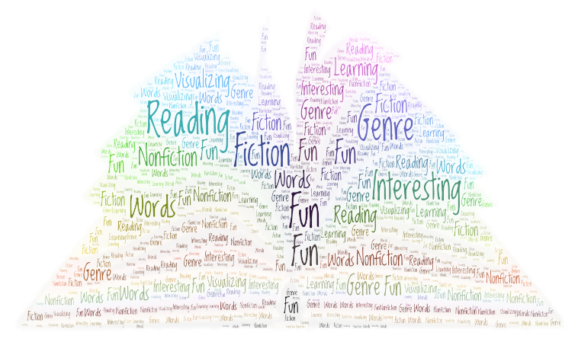

Add and Subtract
• Solve multi-step addition and subtraction problems in contexts, deciding which operations and methods to use and why.
• Add and subtract whole numbers with more than 4 digits, including using formal written methods. (columnar addition and subtraction)
• Add and subtract numbers mentally with increasingly large numbers.
• Use rounding to check answers to calculations and determine, in the context of a problem, levels of accuracy.
• Add and subtract negative integers.

• Use simple formulae.

• Generate and describe linear number sequences.

• Express missing number problems algebraically.

• Find pairs of numbers that satisfy an equation with two unknowns.

• Enumerate possibilities of combinations of two variables.

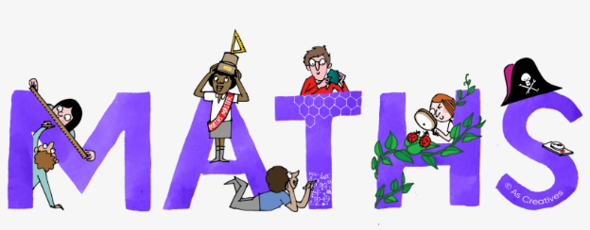

Fractions

Understanding the Properties of Shape

Describe Position Movement and Direction

Measures

Statistics

Algebra

