Spring Writing Competition
Due back to school by Thursday 25th March 2021
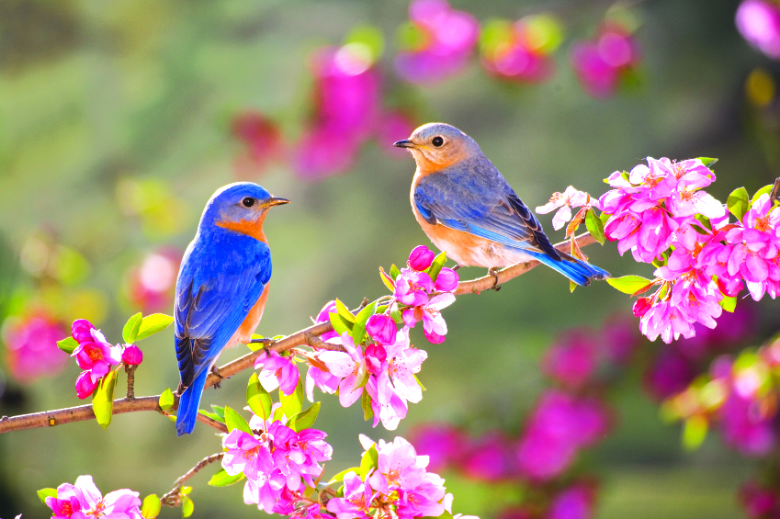

You must write a story or a poem based on the picture above.
Have fun and use your imagination.
I look forward to reading your stories,
Miss Hetherington
P.S. There will be a prize for the lucky winners!

Please bring all entries to my classroom or email:
english@southwickprimary.co.uk

